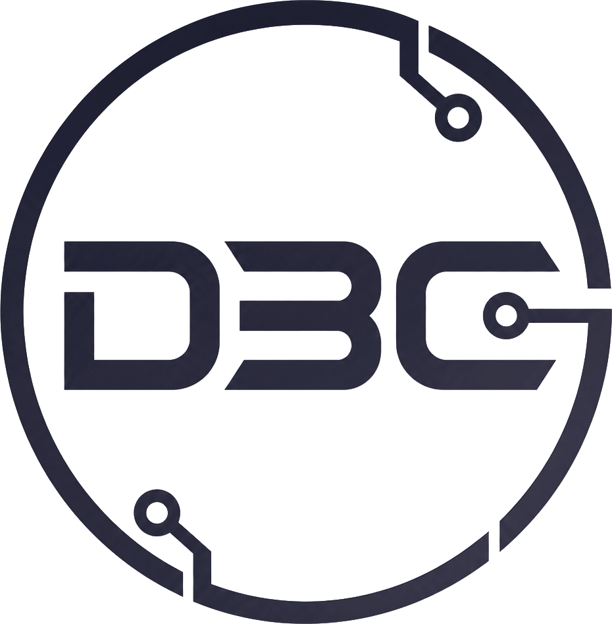 | DOBY BAXTER COMPUTING
Terms of Business
Effective date: 7 August 2026 · Version 1.0. These Terms of Business govern every engagement between Doby Baxter Computing and its clients. They apply alongside the signed Engagement Scope Agreement for each engagement and the Data & Privacy pack (Privacy Notice and DPA). By signing a Scope Agreement that refers to these Terms, the client accepts them.

1 · WHO THESE TERMS ARE BETWEEN
These Terms are between Doby Baxter Computing — a sole-trader business operated by Doby Baxter ("I", "me", "my"), based in the United Kingdom — and the client named in the relevant Engagement Scope Agreement ("you", "your").
Each engagement is defined by its own signed Engagement Scope Agreement, which sets the outcome, systems in scope, deliverables, timeline, and fee. These Terms apply to all engagements and do not need to be re-signed each time; where a Scope Agreement and these Terms differ, the Scope Agreement governs the specifics of that engagement and these Terms govern everything else.

2 · THE NATURE OF MY SERVICES
I take on two kinds of engagement: advisory and audit work, where I assess, test, and review your systems and give you findings, recommendations, and plans; and build and delivery work, where I design and build software, tooling, or configuration and deliver it to you. Each engagement’s type and scope is set in its Scope Agreement.
Deployment is always yours. Whatever the engagement, I deliver work products — reports, recommendations, code, or tooling — for your team to review, accept, test, and deploy. I do not operate, run, or deploy changes into your live or production systems; your own personnel do that, on your decision. Where you grant me access, it is for assessment, testing, and building the agreed deliverables only, and I access the minimum the work requires and nothing more.
You are responsible for implementation. Deciding whether and how to use any deliverable, and carrying out any change to your systems, is your responsibility. Validation tooling, remediation plans, and any code I deliver are provided for your engineers to review, adapt, and deploy; I do not install or execute them against your production environment unless a Scope Agreement expressly says so and sets separate terms for that work.

3 · YOUR RESPONSIBILITIES AND AUTHORIZATION
By entering an engagement you confirm and agree that:
- Authority. You own, control, or are otherwise authorized to permit the assessment and testing of every system, service, and environment named in the Scope Agreement, and you authorize me to carry out the work described — including deliberate failure-mode and negative testing where the Scope Agreement includes it.
- Accurate information and access. You will provide the access, information, and named contact the Scope Agreement requires, and the information you give me is accurate and complete to the best of your knowledge. Delays or gaps here may delay the engagement and change the scope or fee.
- Backups and safeguards. You are responsible for maintaining your own backups and operational safeguards before and during the engagement, including before running any negative test in an environment you nominate for it.
- Indemnity. You will indemnify me against any claim, loss, or cost arising from your not having the authority described above, or from your implementation, non-implementation, or modification of any recommendation or deliverable.

4 · STANDARD OF WORK — WHAT I DO AND DO NOT GUARANTEE
I perform my services with reasonable skill and care, using recognized methods and my professional judgment.
An audit identifies issues that are reasonably discoverable within the agreed scope, access, and time. It cannot guarantee that a system is free of all vulnerabilities or defects, that every possible failure mode has been found, or that no incident will occur. My findings and recommendations are advisory; I do not warrant any particular business or security outcome, and no such guarantee should be read into these Terms or my materials.
My findings and recommendations are a point-in-time assessment: they describe the systems as they were during the assessment window, based on the scope, access, and information available to me at that time. I am not responsible for changes made, or issues arising, after that window, or for anything outside the scope, access, or information the engagement was based on.

5 · LIABILITY
Nothing in these Terms limits or excludes liability that cannot be limited or excluded by law — including liability for death or personal injury caused by negligence, for fraud or fraudulent misrepresentation, or for anything else that cannot lawfully be limited.
Subject to that, and because my services are advisory and you are responsible for implementation:
- I am not liable for any loss or damage arising from your implementation of, failure to implement, or modification of any recommendation or deliverable, or from changes made to your systems by your own personnel or third parties.
- I am not liable for indirect or consequential loss, or for loss of profit, revenue, data, goodwill, business, or anticipated savings, however arising.
- My total aggregate liability for all claims connected with an engagement, whether in contract, negligence, or otherwise, is limited to the total fees you have paid for that engagement.
- You must bring any claim connected with an engagement within 12 months of the date I deliver the relevant deliverable (or, for a phased engagement, the deliverable for the relevant phase); after that period the claim is time-barred.
Each of these provisions operates separately. You acknowledge that the fee reflects this allocation of risk, and that you are responsible for arranging any insurance you consider appropriate for your own systems and data.

6 · FEES, INVOICING, AND LATE PAYMENT
- Basis and amount. As set out in the Scope Agreement (fixed price, per phase, or day rate).
- Deposit. For a first engagement, or where the Scope Agreement says so, a deposit is payable before work begins and is non-refundable once work has started; the amount is set during scoping and stated in your Scope Agreement.
- Payment terms. Invoices are due within 14 days of the invoice date unless the Scope Agreement states otherwise.
- Late payment. I may charge interest and reasonable recovery costs on overdue sums under the Late Payment of Commercial Debts (Interest) Act 1998, and may pause work until overdue invoices are paid.
- Expenses. Any pre-agreed pass-through costs are charged at cost and identified in the Scope Agreement.

7 · INTELLECTUAL PROPERTY
I retain ownership of everything I bring to or develop independently of an engagement — my methods, know-how, templates, and the validation tooling and software I have built (my background IP).
On full payment for an engagement, I grant you a non-exclusive, perpetual licence to use the deliverables and any provided tooling for your own internal business purposes. You own your own data and any materials you supply. I may use general skills, techniques, and know-how gained during an engagement, provided I disclose none of your confidential information.

8 · CONFIDENTIALITY
Each party will keep the other's confidential information confidential and use it only for the engagement. This does not apply to information that is public through no fault of the receiving party, was already known, or must be disclosed by law. Handling of personal data is governed by the Data Processing Agreement in the Data & Privacy pack, which is incorporated into every engagement that involves such data.

9 · SUB-CONTRACTING
I deliver engagements personally. I will not sub-contract any part of the work without your prior written consent.

10 · TERM AND TERMINATION
- Termination. Either of us may end an engagement by giving 14 days' written notice, or immediately if the other commits a material breach that is not remedied within a reasonable period.
- On termination. You pay for all work done and deliverables produced up to the termination date. I return or delete your data in line with the DPA, keeping only records I am legally required to retain.
- Survival. Sections on liability, intellectual property, confidentiality, and data protection continue to apply after an engagement ends.
- Cancellation and withdrawal. The detailed procedure for cancelling, pausing, or withdrawing from an engagement — including your right to cancel if you are not satisfied and the steps to follow, and the circumstances in which I may decline or withdraw from work — is set out in my Cancellation, Termination & Right-to-Decline Policy, which forms part of this pack and expands this section. Where that policy and these Terms differ on cancellation or withdrawal, that policy governs those specifics.

11 · OTHER TERMS
- Not a partnership. Nothing here creates a partnership, employment, or agency relationship; I act as an independent contractor.
- Force majeure. Neither party is liable for delay or failure caused by events beyond its reasonable control; affected timelines are extended accordingly.
- Entire agreement and order of precedence. The Scope Agreement, these Terms, and the Data & Privacy pack are the entire agreement for an engagement. If they conflict: on data-protection matters the DPA prevails; on engagement specifics the Scope Agreement prevails; otherwise these Terms prevail.
- Third-party rights. Only you and I may enforce these Terms. A person who is not a party has no right under the Contracts (Rights of Third Parties) Act 1999 to enforce any of them.
- Governing law. These Terms and each engagement are governed by the laws of England and Wales, and are subject to the exclusive jurisdiction of its courts.

Doby Baxter Computing · reliability engineering, AI-workflow tooling, and forensic reconstruction.

